Day in the Life of the Hudson River 10/13/22
Wayras Park Boat Launch, Poughkeepsie, NY
RIVER MILE: 75.5
Salt Front: ~RM 76
Poughkeepsie Day School– Shira Teich
9 students & 3 adults
N 41°7056’ – W -73°9403’
(Latitude 41°42’32.8’’N & Longitude – 73°56’25.19’’W)
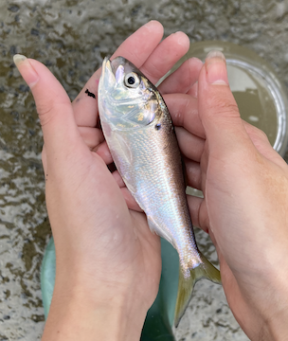 | 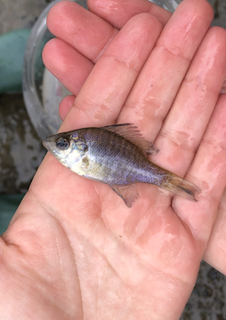 | 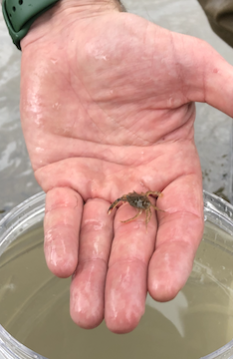 | 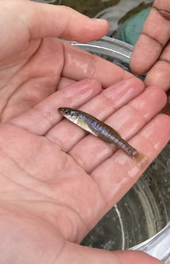

Location: Wayras Park Boat Launch, Poughkeepsie, Dutchess County, NY
Area: public park, pier, grassy, parking lot. Park used for fishing, small boat launch, another pier for small boat launching. Near the walkway over the Hudson in between two bridges in the Mid-Hudson
Sampling Site: Pier, parking lot
Surrounding Land Uses: 100% Urban/Residential
Shoreline: 100% Rocky
River Bottom: NR
Water: NR
Plants in the Water: NR
Things to note! They saw a weasel!
*NR = Not read/recorded
ITEM |  | Time |  | Reading |  |  |  | Comments
Physical
Air Temperature- |  | 11:00 AM |  | 20°C |  |  | 68°F
Wind Speed: |  | 11:00 AM |  | Anemometer  0 mph |  |  | Beaufort  0 | Direction  NR
Weather today |  | 11:00 AM |  | >75% cloud cover |  |  | Start & Stop Rain
Weather the past 3 days: |  | NR
Tides- |  | Time |  | Rising, Falling, Unchanged |  |  | Water Height (cm)
 |  | 10:00 AM |  | NR |  |  | 116 cm
Current- |  | Time |  | Cm/sec |  | Knots | North/South | Ebb/Flood/Still
 |  | 9:30 AM |  | 16.9 |  | NR | NR | NR
Water Temperature- |  | 11:00 AM |  | 20°C |  |  | 68°F
Turbidity- Long Sight Tube (120 cm) |  | 11:00 AM |  | 37.2 cm
Chemical
Salinity-Hydrometer |  | 10:15 AM |  | *10 ppt |  |  | *Beyond reasonable range
Standardized Salinity – LR Quantabs |  | NR |  | 96 ppm
DO – NR |  | Time |  | Temp |  |  | ppm DO | % saturation
pH – Color Match Kit |  | 11:00 AM |  | 7
Nitrates- NR
Phosphates- NR
Alkalinity- NR
Biological-
Fish – Seine |  | Number |  | Name |  |  | Length of longest | Length of smallest
10:30 AM-11:00 AM – 3 pulls |  | 1  17  1 |  | Atlantic Menhaden  Banded Killifish  Bluegill sunfish |  |  | 13 cm  10 cm | -  7 cm
Fish Totals |  | TOTAL: 19 |  | Diversity: 3z
Macroinvertebrates |  | Number |  | Name |  |  | Length of longest | Length of smallest
 |  | 2 |  | Blue Crab |  |  | 3 cm | 2 cm
Macroinvertebrate Totals |  | TOTAL: 2 |  | Diversity:1
Sediment Core –NR
Length | H2S smell |  | Oxid Top |  | Oil |  | Grain Size | Other Features
Boats- NR
 | Time |  | Name |  | Color |  | North/Southbound | Light/Loaded
Commercial
Recreational

